EXPERIMENT NO-19:STUDENT-TEACHER-SUB-CODE
Aim
To implement a Prolog database that stores relationships between students, teachers, and subject codes, and allows queries to retrieve information.
Algorithm
- Define facts in the database using student_teacher(Student, Teacher, SubCode).
- Store multiple entries with different students, teachers, and subject codes.
- Write queries to:
  - Find the teacher for a given student and subject code.
  - Find all students taught by a given teacher.
  - Find which subject code a student is enrolled in.
- Execute queries to display results.
Prolog Code
prolog
% Database: Student - Teacher - Subject Code

% Facts
student_teacher('Alice', 'Dr.Smith', 'CS101').
student_teacher('Bob', 'Dr.Smith', 'CS101').
student_teacher('Charlie', 'Prof.Jones', 'MA201').
student_teacher('Diana', 'Prof.Jones', 'MA201').
student_teacher('Eve', 'Dr.Brown', 'PH301').

% Rule: Get Teacher by Student and Subject Code
get_teacher(Student, SubCode, Teacher) :-
student_teacher(Student, Teacher, SubCode).

% Rule: Get Students by Teacher
get_students(Teacher, Student) :-
student_teacher(Student, Teacher, _).

% Rule: Get Subject Code by Student
get_subject(Student, SubCode) :-
student_teacher(Student, _, SubCode).
Output
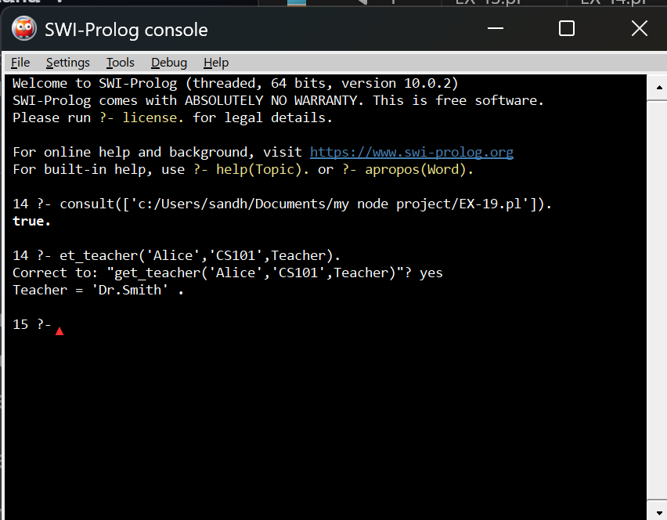
Result
The Prolog program successfully stores and retrieves relationships between students, teachers, and subject codes. It can answer queries such as:
- Which teacher teaches a student in a given subject?
- Which students are taught by a particular teacher?
- Which subject code is assigned to a student?

